MOVIE NIGHT

“DALAI LAMA Renaissance”
(Narrated by Harrison Ford)

"Everybody thinks of changing humanity, and nobody thinks of changing himself."
- A quote from “Dalai Lama Renaissance”
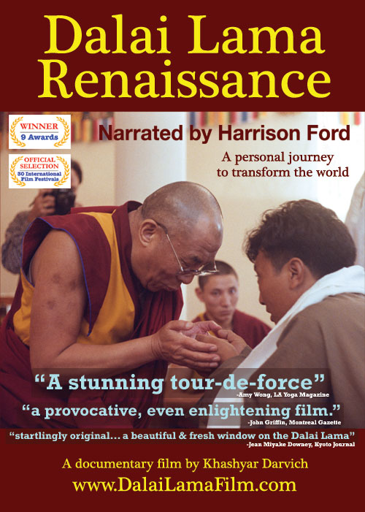
“Join us for a two night journey of transformation with His Holiness the Dalai Lama”

20th December Vol 1 'Dalai Lama Renaissance': A journey of 40 of the West’s most innovative thinkers to meet with the Dalai Lama to discuss the world’s problems and how we can solve them. What transpired was unexpected and powerful.
21st December Vol 2 ' A Revolution of Ideas': A continuation of the journey. With humour and profound insight, the Dalai Lama inspires our hearts and minds with some of the greatest wisdom of our Age.
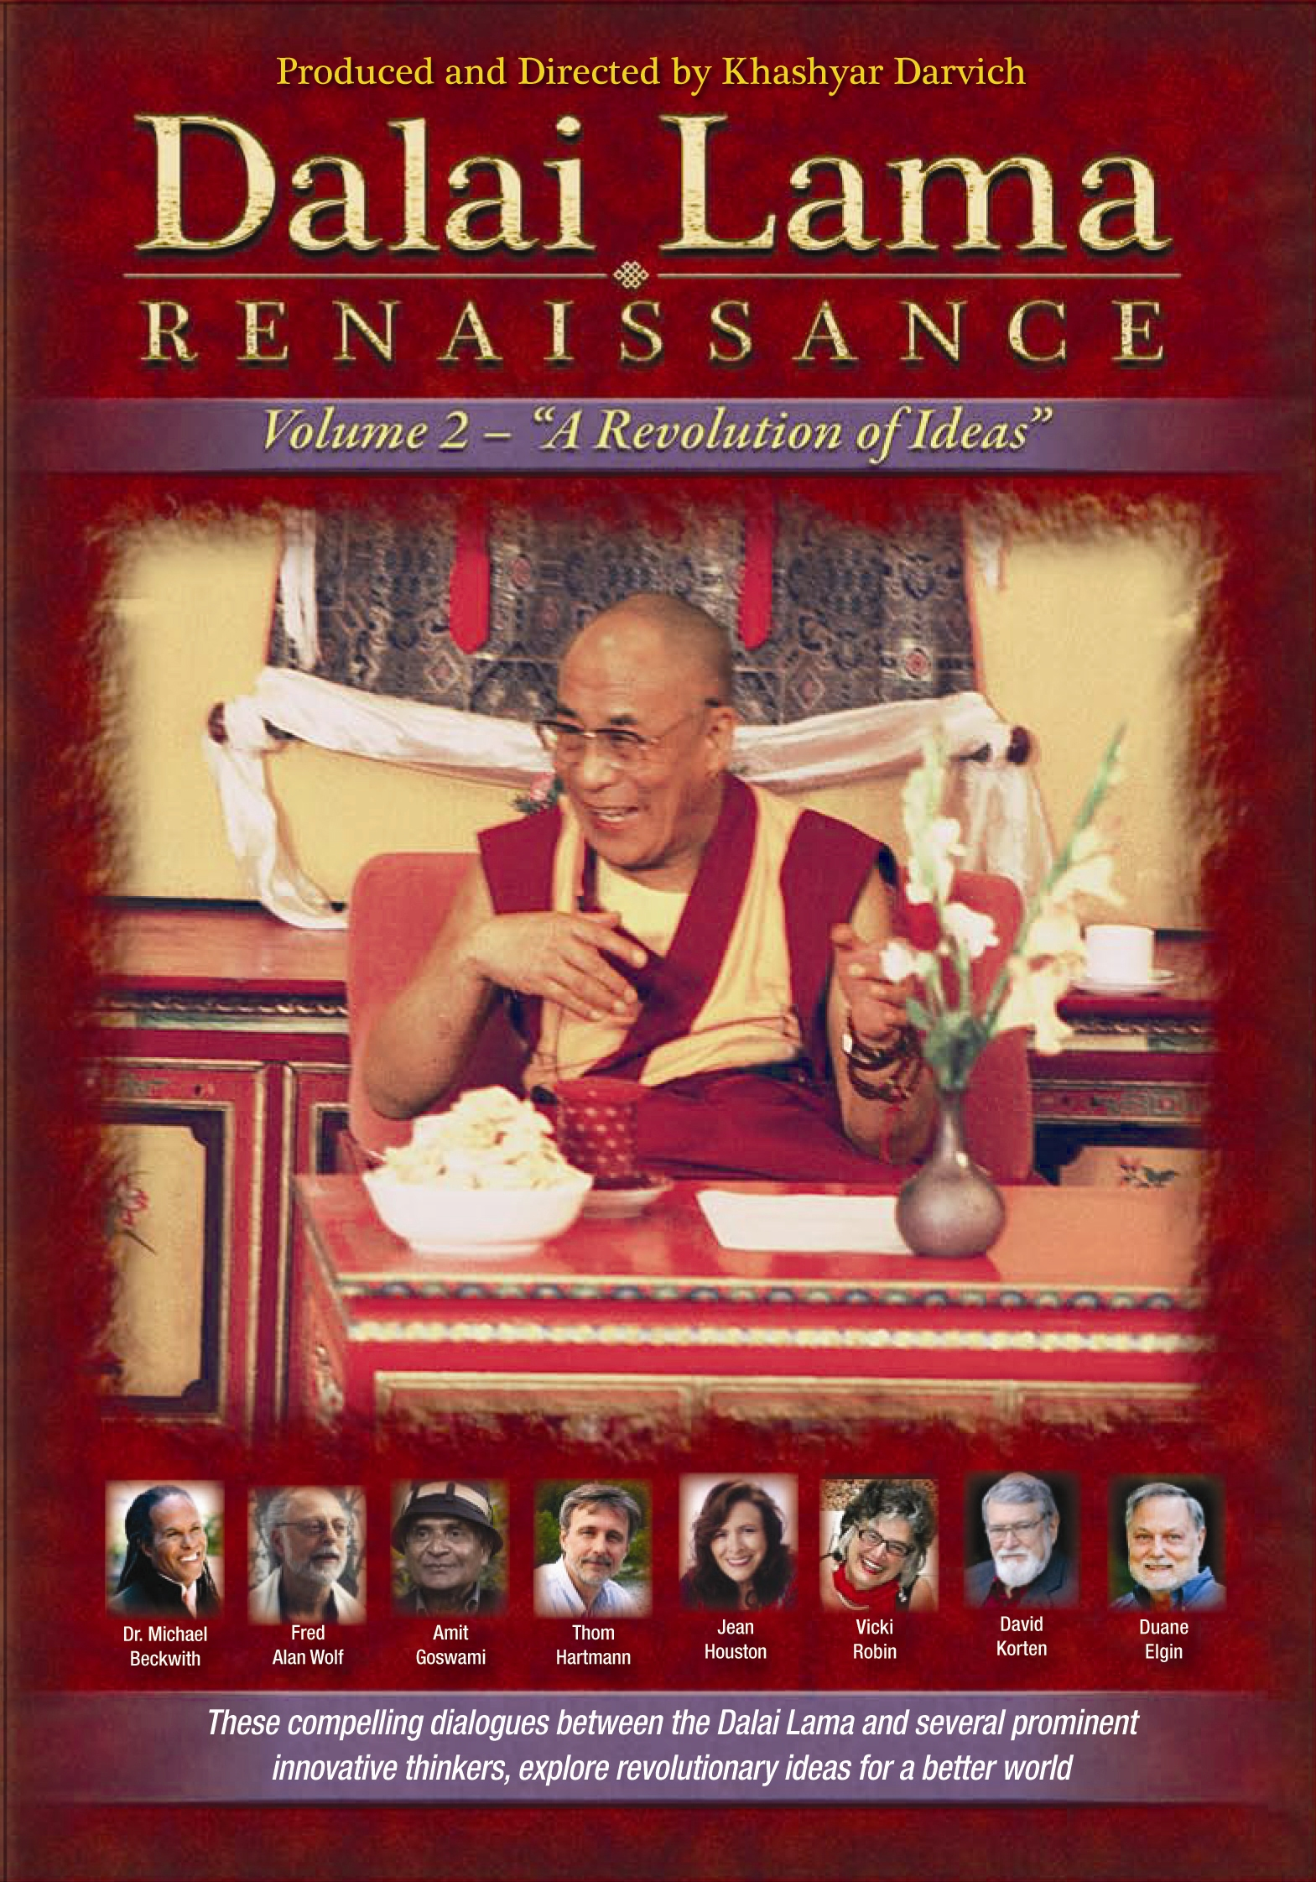After each screening of Vol 2 we will have the privilege of director, Khashyar Darvich’s company to speak about the transformative theme of the film, not just speaking about how the film was made, but rather helping guide the audience to employ the story and message of the film so that they go more deeply into themselves. It is highly recommended to see both films and to see Vol 1 before Vol 2.

‘Dalai Lama Renaissance’ has screened in front of sold out film festival audiences throughout the world, has received many positive reviews, has won numerous awards at international film festivals, and has touched, impacted and inspired many thousands of people.

The main intention and goal in producing ‘Dalai Lama Renaissance’ was to inspire and positively impact as many audiences as possible. Making "Dalai Lama Renaissance" available to as many audiences as possible is important so that the film fulfils its purpose of serving the Highest Good of others.
The Movie night has been organized by Little Seeds Project to raise the funds for PCYC, Albany and The Tara Children’s Project, Bodhgaya, India.

Tara Children’s Project is in desperate need of funds if it is to continue to provide Health Care and Education as well as a home for children with HIV+/AIDS.

At a time of the year when so many of us look externally for joy and happiness, this thought provoking evening will take you on a journey of self discovery within.

Dates: Monday 20th & Tuesday 21st December 2010
Time: Pt 1: 5.00pm Pt 2: 7.30pm
Venue: 77 Sandford Road, Albany WA (PCYC)
Tickets: (Pt 1): $25 (Pt 1&2): $40

